



Friday, April 10, 2026 | 7:30 AM–3:00 PM

This year's second Quarterly Recycling Drive is fast approaching and has a new location!
Due to new, ongoing active construction zones, the next Quarterly Recycling Drive will be at the parking lot on 6th Avenue, between Sanders Street and 8th Avenue next to the Metcalf Building. See map below.
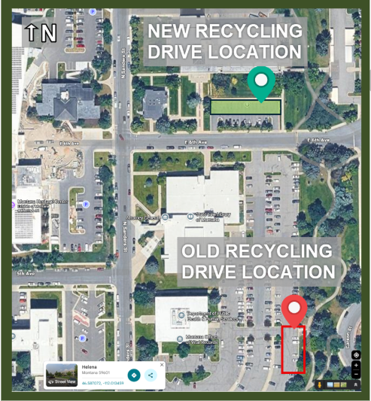

Additional information about allowable recycling materials will be sent out prior to 4/10/2026. Thank you for participating and making this Quarterly Recycling Drive a success!

MONTANA DEPARTMENT OF ADMINISTRATION
GENERAL SERVICES DIVISION
1310 E Lockey Ave | Helena, MT 59601 | (406) 444-3060 | GSDServiceDesk@mt.gov

